Analysis and Design

Yaseen Mohamed (B032220060)

Flow Chart 1.1: Main menu function.
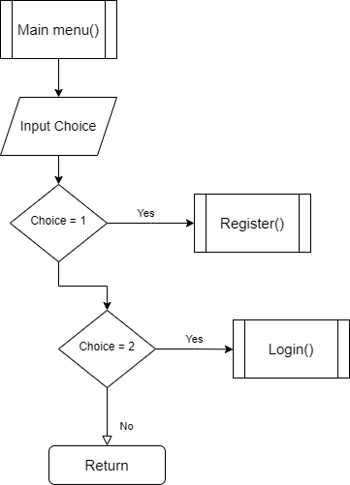

Flow chart 1.2: Register function.
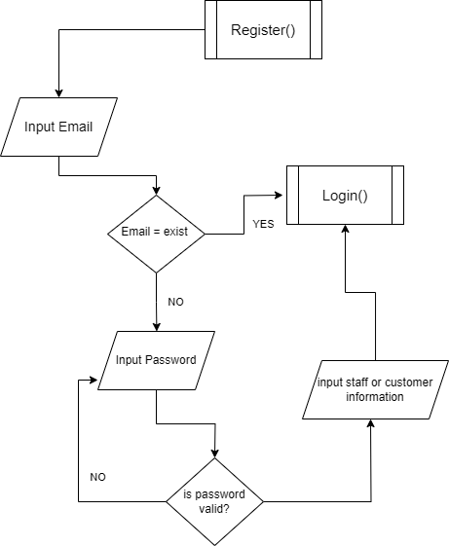

Flow chart 1.3: Login function.
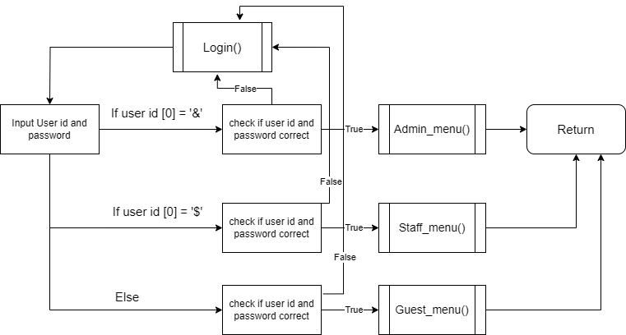
Flow Chart 1.4: Admin_menu function.
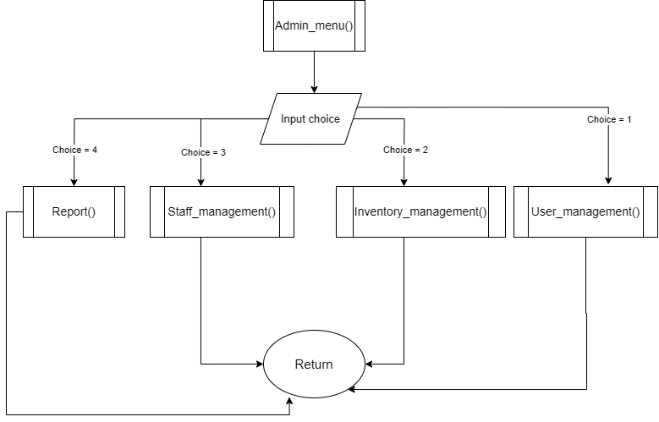

Flow chart 1.5: Staff_Menu function.
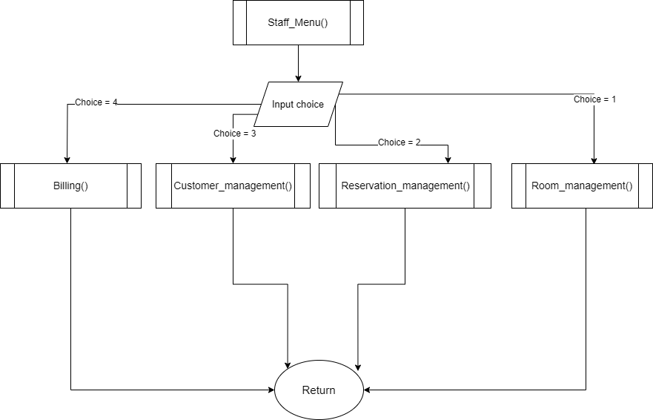
Flow chart 1.6: Customer_Menu function.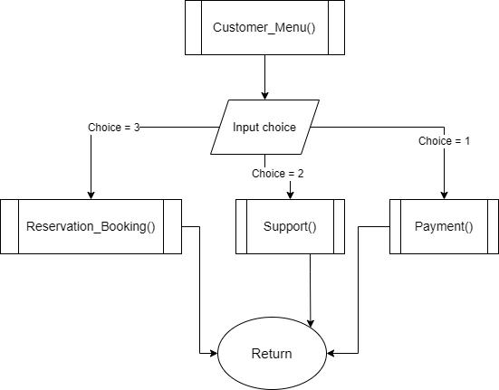

ERD:
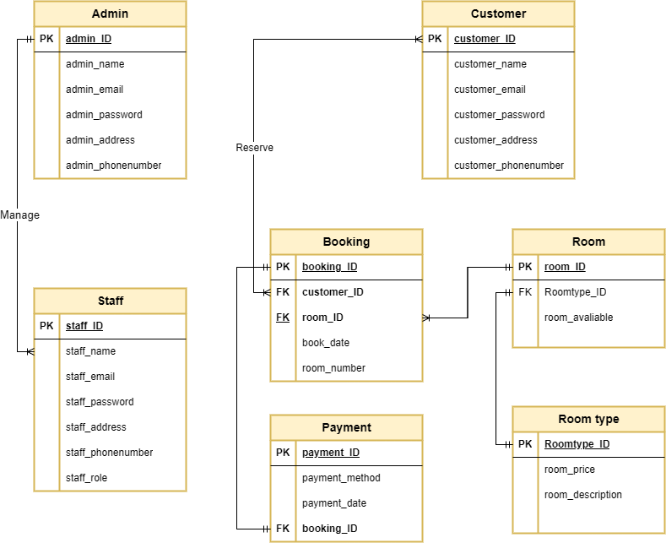
Business rule:
- customer can have one or many booking

- room can be booked one or many times

- booking can be made by one or many customers

- Admin can manage one or many staff members

- A room must have a specific room number

- A payment must be made for a booking

- Staff can be managed by one and only one admin

- Room can have one and only one room type
Data dictionary:
ADMIN TABLE
Attributes | Data type | Unique | PK/FK
Admin_ID | Varchar(15) | YES | PK
Admin_name | Varchar(25) | - | -
Admin_email | Varchar(30) | Yes | -
Admin_password | Varchar(35) | - | -
Admin_address | Varchar(50) | - | -
Admin_phonenumber | INT | - | -

STAFF TABLE
Attributes | Data type | Unique | PK/FK
Staff_ID | Varchar(15) | YES | PK
Staff_name | Varchar(25) | - | -
Staff_email | Varchar(30) | YES | -
Staff_password | Varchar(35) | - | -
Staff_address | Varchar(50) | - | -
Staff_role | varchar(20) | - | -
Staff_phonenumber | INT | - | -
CUSTOMER TABLE
Attributes | Data type | Unique | PK/FK
Customer_ID | Varchar(15) | YES | PK
Customer_name | Varchar(25) | - | -
Customer_email | Varchar(30) | YES | -
Customer_password | Varchar(35) | - | -
Customer_address | Varchar(50) | - | -
Customer_phonenumber | INT | - | -

BOOKING TABLE
Attributes | Data type | Unique | PK/FK
Booking_ID | Varchar(15) | YES | PK
Customer_ID | Varchar(15) | - | FK
Room_ID | Varchar(15) | - | FK
Booking_date | Varchar(15) | - | -
Room_number | INT | - | -

PAYMENT TABLE
Attributes | Data type | Unique | PK/FK
Payment_ID | Varchar(15) | YES | PK
Booking_ID | Varchar(15) | - | FK
Payment_method | Varchar(20) | - | -
Payment_date | Varchar(15) | - | -

ROOM TABLE
Attributes | Data type | Unique | PK/FK
Room_ID | Varchar(15) | YES | PK
Roomtype_ID | Varchar(15) | - | FK
Room_avaliable | Varchar(20) | - | -

ROOMTYPE TABLE
Atrributes | Data type | Unique | PK/FK
Roomtype_ID | Varchar(15) | Yes | PK
Room_price | INT | - | -
Room_desc | Varchar(40) | - | -

